SECUREIN ASSIGNMENT

**PART A OUTPUT**

**1. How many total combinations are possible?**

The total combinations can be calculated by multiplying the number of faces on each die.

Total Combinations = (Number of Faces on Die A) X (Number of Faces on Die B)

Total Combinations=(Number of Faces on Die A) X (Number of Faces on Die B)

Total Combinations = 6X6 = 36

**2. Calculate and display the distribution of all possible combinations that can be obtained when rolling both Die A and Die B together. Show the math along with the code!**

Each combination (DieA,DieB) represents a unique outcome when rolling Die A and Die B together.

The outer loop iterates through all faces of Die A, and the inner loop iterates through all faces of Die B, generating all possible pairs.

**3. Calculate the Probability of all Possible Sums occurring among the number of combinations from (2).**

**Example: P(Sum = 2) = 1/X as there is only one combination possible to obtain**

**Sum = 2. Die A = Die B = 1.**

Total combinations (X) when rolling two six-sided dice: X = 6 × 6 = 36

Probability of Sums: For each possible sum (S) from 2 to 12, calculate the probability

(P(S)) using the formula: P(S) = (Number of combinations for Sum S)/X

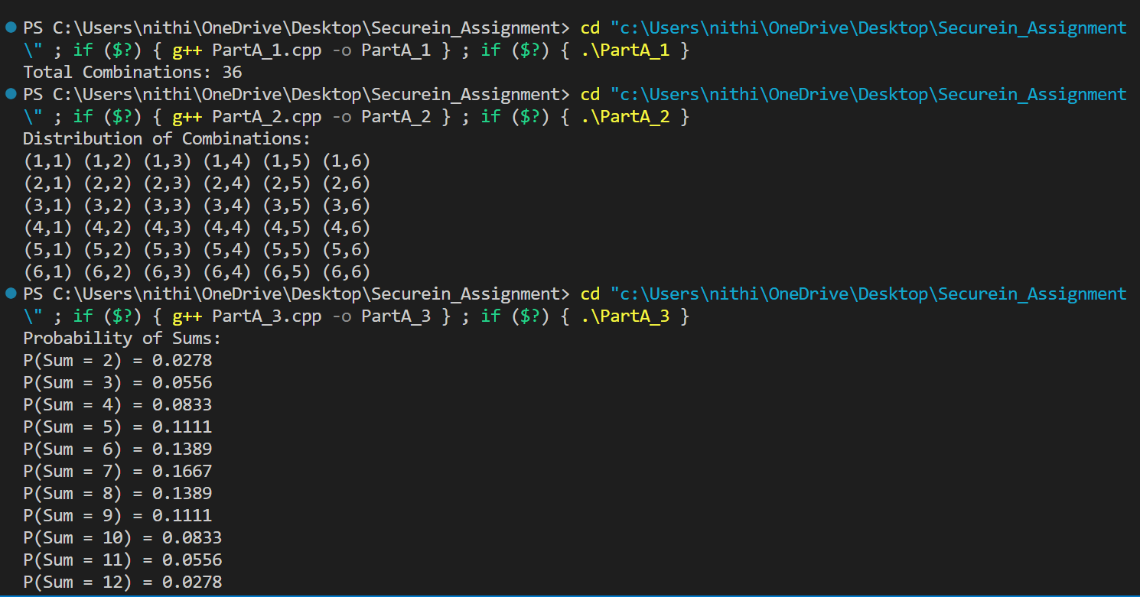

**PART B OUTPUT**

Finding Next Die Combinations:

Recursively explore different spot values for each face of the die. Ensure that the sum of spots on the die faces is used to calculate the probability distribution later.

Probability Matching:

Compare the obtained probability distribution with a target probability distribution designed to match the distribution of sums for two six-sided dice. Consider all possible combinations of spots on two dice to calculate the probabilities.

Undooming Dice:

Explore different combinations of spots for Die A, assuming constraints. For each combination of Die A, find corresponding spots for Die B to match probabilities. If a valid combination is found, return the undoomed dice.

